**Name ________________________________________ Date ____/____/____**

**Do Now for Making Connections State Lab Pd. ______**

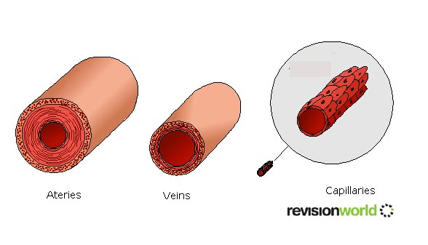

1. **Label the three blood vessels below, and write its function.**

**_______________________ _____________________ __________________________**

**_______________________ _____________________ __________________________**

1. **What is another term for The Circulatory System?**

**______________________________________________________________________________**

1. **What is the difference between the dependent and independent variables?**

**_____________________________________________________________________________**

**_____________________________________________________________________________**

1. **What do researchers do to advance science?**

**______________________________________________________________________________**

**Name:** _________________________ **Date:** _________________

**Making Connections Lab Report Rubric**

|  |  |  |  |
| --- | --- | --- | --- |
|  | **Not Yet** | **Meets Standards** | **Exceeds Standards** |
| **Collect and record data following a scientific procedure** |  | ___ Adequately follows directions to gather data while correctly using the appropriate scientific tools and technologies, which includes:  ___ Data Table Headings  ___ Accurate Measurement  ___Decimal Placement  ___Appropriate Units | __ Independently chooses and effectively uses the appropriate scientific tools to gather data during a scientific inquiry  __ Measurements are specific and highly accurate |
| Ways to improve BE PRECISE: | | | |
|  | **Not Yet** | **Meets Standards** | **Exceeds Standards** |
| **Transfer scientific data onto a graph** |  | The student organizes, transforms and presents data in numerical and/or visual forms. This may include:  __ use the appropriate type of graph  __ Appropriate scales  __ Accurate Data placement  __ Appropriate Independent Variable and Dependent Variable Placement | __ The student organizes, transforms and presents data in numerical and/or visual forms logically, correctly, and consistently. |
| Ways to improve:  __ Include an appropriate title __ Include an appropriate key | | __ Ensure all data points are accounted for  __ Ensure data and/or numbers are precisely placed in the appropriate location __ Other | |
|  | **Not Yet** | **Meets Standards** | **Exceeds Standards** |
| **Form conclusions from data and/or observations** |  | __ Student writes a logical conclusion supported by data and /or observations | __ Student writes a logical conclusion and expands with additional relevant examples, evidence, and/or data |
| Ways to Improve:  __ Add a clear topic sentence __ Use statistical evidence or data __ Cite a specific source | | __ Use appropriate scientific vocabulary  __ Expand on your conclusions with an example  __ Draw a clear connection between the topic sentence and evidence __ Other: | |
|  | **Not Yet** | **Meets Standards** | **Exceeds Standards** |
| **Develop and apply necessary steps for academic achievement** |  | ____Adheres to deadlines ____Demonstrates evidence of planning steps  __homework       __ researching  __ drafts               __ goal sheet  __ questions        __ reviewing  __ other                __ calendar | ____Consistently adheres to deadlines ____Demonstrates student created evidence of planning steps  __homework           __ researching  __ drafts                   __ goal sheet  __ questions            __ reviewing  __ other                    __ calendar |
| **Ways to Improve:**  __Other:   _ Use a planning calendar or agenda | | ___utilizing your time in class more effectively  ___ set smaller goals or deadlines in order to complete the task at a more appropriate pace/on time  ___ consider completing some/more of the work outside class | |

